Grade 4
Car Race

Description: | Students will:  Draw a car and script it to move.  Create a variable called speed, add a random number generator tile to it and use it to move the car forward on the race track.  Add two or three other cars with the same basic script.  Write test statements for each car to race and then stop the racing when the first car crosses the finish line.  Write a script that makes a winner’s flag show at the finish and hide when the race is reset.  Write a reset script using x and y coordinates to position the race cars at the start line evenly spaced apart and at the same distance above the lower edge of the race track.  Create a graphical tally of the race results and keep the tally information in a flap made for this project.  Discuss race results and compare their results with those of nearby students. Analyze similarities and differences.
Project View | 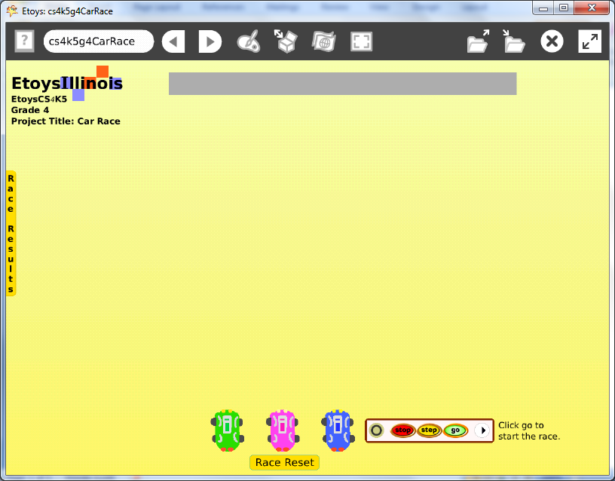
Subject: | Math
Etoys Quick Guides | Click the question mark in Etoys to open the set of interactive tutorials for basic tools and techniques.
Vocabulary: | X axis, Y axis, heading, variable, random number generator
Lesson 1:  Script Tiles: Forward by  Menu Tools: Viewer Icons  Menus: Viewer Icons Set  Menu: Scriptor Icons Set | Draw a car and keep it.  Create a script with a forward by tile.  Create a variable called speed: click on the V in the top line of the car’s Viewer to open a dialogue box, type the word speed.  Pick up the speed tile by the first part of the tile and drop it onto the number in the forward by tile. These two tiles will lock together.  Click on the Supplies box in the top border of the car’s scriptor and add a random number tile to the variable tile. This tile will lock into place too.  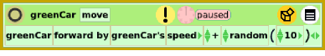  Name the car by its color and add the word move. Naming objects and scripts helps keep ideas organized.  Experiment with this script. The range of numbers used for the speed can be wide or narrow. The range of numbers for the random number variable can be wide or narrow too. Give students time to experiment.  Keep this project: nameCarRace
Lesson 2:  Halo Handles: Size, Color, Copy  Menus: Button to Fire a Script | Make copies of the car, as many as you want, and repaint each a different color. Make the headlights a different color for each car so that this color can be used to test which car touches the finish line first.  Draw a finish line. Lock it using the white menu in its halo of handles so that it does not move or get thrown away. Its color is used in test statements that will help determine the winner of each race.  Open a viewer for each car and find the script that was made for the original car.  Line up all the cars near the lower edge of the screen, use an All Scripts button from Supplies to start and stop all the cars at one time.  Rather than moving the cars back to the start with the mouse each time, line up all the cars using the value in the Y axis tile and space them using their X axis values evenly apart.  Make a reset button using x axis and y axis tiles to align and space evenly. Leave the ticking state as Normal and make a button to fire this script.  Keep the project.
Lesson 3: | Test to show the winner of each race  Each car will have a test that will pause its script and the other cars’ scripts as soon as one of the cars touches the finish line.  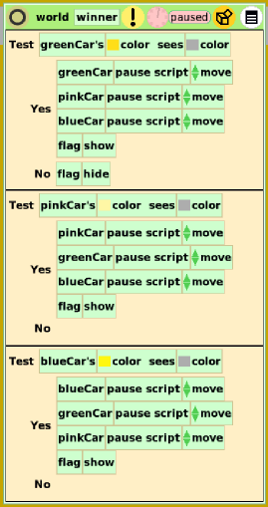
Lesson 4 Script Tiles: Hide and Show  Object Catalog: Maker Button | Draw a winner’s flag, keep it and open its viewer. Put it near the finish line and give it a heading slightly larger than zero.  Make a script for the flag so it turns about 15 degrees and then pauses. Add a test statement.  Open the Miscellaneous category for the hide and show tiles to use in the winner script. Think about when the flag should show and when it should hide.  Make a reset script  Use the Viewer for the world and make one script there that puts all the cars in starting locations. This same script controls when the winner’s flag is visible and when it is not visible. Each car has a similar test but will refer to different cars.  Test statements are in the Viewer or in the top border of the Scriptor. Give students time to think about what must happen and how they can arrange the statements to do what they want. The pause script tiles are found in the Scripting category.  The colors of each car’s headlights are slightly different shades of yellow and those are the colors referred to in the top line of each test.  Give students time to add other details that will give make this project look like a commercial game they might play.
Lesson 5  Script Tiles: Scale Factor  Supplies: Add a New Flap | Make a graphical tally  Ask students to tally the number of times each car wins. A graphical representation can be made using Maker Buttons.  Copy the cars, use the geometry category and change the scale to .20 or some other value that suits the size and scale of the other objects in the project. Change the ticking state from Paused to Normal so that these cars do not move when being used to tally the winners.  Open the Object Catalog from Supplies and get Maker Buttons from the Connections category. Put each small car on a Maker Button to provide an endless supply for the tally.  Make a flap to store these small cars so that students can see them accumulate over time.  Use the flap’s white menu to place it on sides top or bottom of the window The white menu also has options to change the color and the label. Name the flap something like Results, Race Results, or Winners.  Keep the project.
Lesson 6 | Give students time to experiment, to change the range of the random variable in each script and think about the effects. Should all the ranges be the same? What variables are found in real cars in races? Discuss.  Keep this project and give students time to experiment with it. Given time, many students will explore the range of random variables and add additional graphical features to their race event. Give students time to look at other race projects and to add the features they like.  These decisions by students are where and when analysis, synthesis and evaluation occur.  Discuss race results. Tally 20 runs analyze results and compare car to results with neighbor’s results. Discuss differences.  Keep the project after races have been run and results tallied in the flap to take a longer view of randomness.
Standards: | Common Core Standards  Mathematics: 4.OA2.5; 4.NF.6.7  Bloom’s Taxonomy/Cognitive Domain:  Knowledge: knows  Comprehension: explains  Application: uses  Analysis: analyzes  Synthesis: predicts  Evaluation: compares  NETS  1. a, b, c  3. a, b, d  4. a, b, c, d
Resources: | Etoys Help Quick Guides: always available in Etoys. Open Etoys and click the question mark to open a set of interactive tutorials of basic tools and techniques.  www.etoysillinois.org projects, lesson plans, software download  www.mste.Illinois.org more math, science, and technology resources  www.corestandards.org Common Core Standards  www.squeakland.org software and Etoys projects  www.nctm.org Standards and Focal Points for each grade level
kh January 2011

